**Association between Bacillus Calmette-Guérin** (**BCG) Vaccination and Leprosy among Patients in East Africa: Case-Control Study**

**Background:** Leprosy is an infectious disease that may lead to significant disability when untreated.1 The bacterium that causes leprosy is closely related to the bacterium that causes tuberculosis.2 Given this similarity, it is possible the tuberculosis vaccine, Bacillus Calmette-Guérin (BCG), may provide protection against leprosy. This study aims to examine the protective association between the BCG vaccination in early childhood and leprosy. We hypothesize that patients who received the BCG vaccination in early childhood have a lower odds of leprosy, after adjusting for potential confounders and other important covariates.

**Study Design & Methods:** This was an unmatched case-control study of patients in East Africa. The study included 274 patients with leprosy (cases) and 1096 patients without leprosy from a cross-sectional survey of the population (controls). The exposure was BCG vaccination in early childhood, which was determined by presence or absence of a characteristic scar. The outcome was newly diagnosed leprosy. In addition, patients’ sex, age group, housing and years of schooling were recorded. The data and related information were provided by instructors.

**Statistical Analysis:** Descriptive statistics were used to describe baseline characteristics, including sex, age group, housing, and years of schooling (Table 1). Using multivariable logistic regression, we modeled the association between BCG vaccination and newly diagnosed leprosy, adjusting for age, sex and housing.



where I is an indicator function that takes value of 1 or 0; BCG vaccination status is an indicator variable for presence of BCG vaccination scar; Sex is an indicator variable for female; Age is divided into ordinal groups from the youngest to the oldest, with “5-9 years” serving as the baseline group (group 1); Housing is the type of housing, with “Brick” serving as the baseline group (group 1). The model was developed based on the directed acyclic graph (Figure 1). Age was included in the model as a confounder, as few patients in East Africa over age 30 received the vaccine and leprosy incidence tends to peak in early adulthood.3 Sex was included as an important precision variable since males are shown to have a much higher incidence rate of leprosy than females in most regions.4 Type of housing was included as a potential confounder. Assuming housing partially reflects socioeconomic status, we presumed that children living in poor housing have lower BCG vaccination rates due to resource limitations and they also may be more vulnerable to leprosy infections due to lack of access to healthcare resources and hygienic living environment with safe social spacing. Schooling was considered neither as a confounder nor a scientific interest, so it was not included in the model.

**Results:** After excluding 123 patients with missing housing data, our statistical analysis was based on 249 cases and 998 controls, 53% being women and 40% with BCG vaccination. After adjusting for sex, age group and housing, we estimate that the odds of having leprosy among patients with BCG vaccination scar is 0.34 (95% CI 0.23 - 0.51) times the odds of having leprosy among patients without BCG vaccination scar. We have strong evidence to reject the null hypothesis that there is no association between the odds of leprosy and BCG vaccination in early childhood, adjusting for sex, age group and housing condition (p<0.001).

**Discussion:** We found the odds ratio of leprosy comparing patients with and without BCG vaccination scar is 0.34 (95% CI 0.23 - 0.51), adjusting for sex, age group and housing.The study design is effective in collecting sufficient data on patients with leprosy, given that leprosy is a rare disease with a global prevalence of 0.34 per 10000 in 2019.5 Additionally, since all the cases were newly diagnosed and the BCG vaccination scar traces back to early childhood, the temporality of association can be established. However, causal inference cannot be drawn due to unmeasured confounders, such as immunosuppression. Furthermore, since age is arbitrarily grouped, the model forces the odds ratio to be equal within each age group. The step function is biologically implausible and does not borrow information from people with similar ages but in different age groups. Adjusting for age as an indicator variable may lead to residual confounding within the same age group, especially within the wider age groups.

**Tables and Figures**

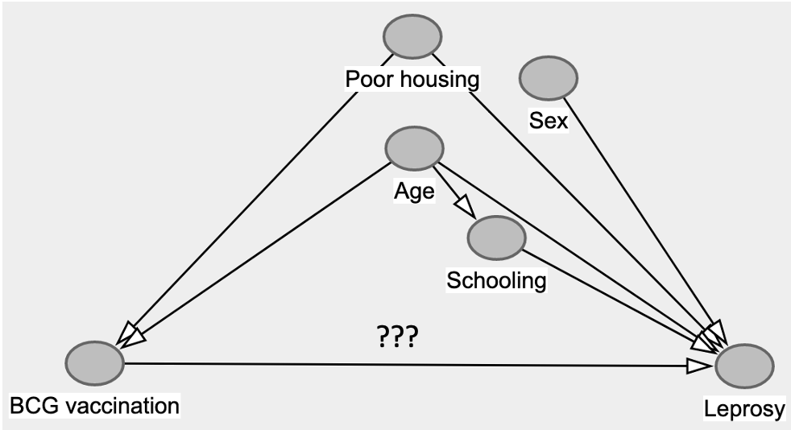

**Figure 1: Directed Acyclic Graph (DAG) for Proposed Model.**

Our exposure of interest is BCG vaccination and outcome of interest is diagnosis of leprosy.

??? designates the association of interest. Age and housing were treated as confounder variables. Sex was treated as an important precision variable. Schooling was considered neither as a confounder nor a scientific interest, and it was not included in the model.

**Table 1: Baseline characteristics of 1247 patients included in analysis.**

Number of patients in each group are displayed with corresponding percentage based on grouping (patients with leprosy (cases) and patients without leprosy (controls)).

|  |  |  |
| --- | --- | --- |
|  | **Patients with Leprosy**  **(n=249)** | **Patients without Leprosy**  **(n=998)** |
| **Presence of BCG Vaccination Scar, n (%)** |  |  |
| Yes | 42 (17%) | 451 (45%) |
| No | 207 (83%) | 547 (55%) |
| **Sex, n (%)** |  |  |
| Male | 101 (41%) | 490 (49%) |
| Female | 148 (59%) | 508 (51%) |
| **Age, n (%)** |  |  |
| 5-9 years | 32 (13%) | 237 (24%) |
| 10-14 years | 30 (12%) | 185 (19%) |
| 15-19 years | 19 (8%) | 153 (15%) |
| 20-24 years | 16 (6%) | 85 (9%) |
| 25-29 years | 30 (12%) | 52 (5%) |
| 30-44 years | 58 (23%) | 124 (12%) |
| 45+ years | 64 (26%) | 162 (16%) |
| **Years of School, n (%)** |  |  |
| None | 81 (33%) | 189 (19%) |
| 1-5 years | 114 (46%) | 446 (45%) |
| 6-8 years | 34 (14%) | 291 (29%) |
| sec/tert | 1 (<1%) | 30 (3%) |
| Unknown | 19 (8%) | 42 (4%) |
| **Housing, n(%)** |  |  |
| Brick | 33 (13%) | 207 (21%) |
| Sun Brick | 58 (23%) | 237 (24%) |
| Wattle | 151 (61%) | 528 (53%) |
| Temporary Housing | 7 (3%) | 26 (3%) |

**Table 2: Multivariable logistic regression testing the association between BCG vaccination and diagnosis of leprosy**

BCG: Bacillus Calmette-Guérin; CI: Confidence interval

p-value <0.05 was deemed statistically significant

*Reference group: 5-9 year-old male who did not receive BCG vaccination and live in Brick housing

|  |  |  |  |
| --- | --- | --- | --- |
|  | **Developing Leprosy** | | |
| **Predictors** | **Odds ratio** | **95% CI** | **p-value** |
| BCG vaccination [Yes] | 0.34 | 0.23 – 0.51 | **<0.001** |
| Age 10-14 | 1.26 | 0.73 – 2.18 | 0.402 |
| Age 15-19 | 1.18 | 0.62 – 2.18 | 0.607 |
| Age 20-24 | 1.53 | 0.77 – 2.94 | 0.214 |
| Age 25-29 | 3.39 | 1.85 – 6.20 | **<0.001** |
| Age 30-44 | 2.28 | 1.38 – 3.82 | **0.001** |
| Age 45+ | 1.95 | 1.20 – 3.22 | **0.008** |
| Sex [Female] | 1.23 | 0.92 – 1.66 | 0.163 |
| House [Sunbrick] | 1.29 | 0.80 – 2.12 | 0.303 |
| House [Wattle] | 1.62 | 1.07 – 2.52 | **0.026** |
| House [Temp] | 1.37 | 0.50 – 3.37 | 0.508 |

**R Code**

##Table 1

case<-subset(lep, D==1)

table(case$BCG)

table(case$sex)

table(case$age)

table(case$school)

table(case$house)

control<-subset(lep, D==0)

table(control$BCG)

table(control$sex)

table(control$age)

table(control$school)

table(control$house)

##Build model

mod<-glm(D~BCG+sex+age+house, data=leprosyCCstudy, family="binomial")

summary(mod)

##Compute exponentiated coefficients and CIs

exp(coefficients(mod))

exp(confint(mod))

**References**

1. Organization WH. Leprosy (Hansen’s disease). <https://www.who.int/news-room/fact-sheets/detail/leprosy>. Accessed November 19, 2021.

2. Keragala B, Herath H, Janapriya G, et al. Coexistence of mycobacterial infections - Mycobacterium tuberculosis and Mycobacterium leprae - in Sri Lanka: a case series. *J Med Case Rep.* 2020;14(1):101.

3. Walker SL, Withington SG, Lockwood DNJ. 41 - Leprosy. In: Farrar J, Hotez PJ, Junghanss T, Kang G, Lalloo D, White NJ, eds. *Manson's Tropical Infectious Diseases (Twenty-third Edition).* London: W.B. Saunders; 2014:506-518.e501.

4. Liu YY, Yu MW, Ning Y, Wang H. A study on gender differences in newly detected leprosy cases in Sichuan, China, 2000-2015. *Int J Dermatol.* 2018;57(12):1492-1499.

5. Thomas L. Leprosy Epidemiology. News-Medical. <https://www.news-medical.net/health/Leprosy-Epidemiology.aspx>. Published 2019, January 25. Accessed November 22, 2021